**DAX FUNCTIONS**

MEASURES:

1. Total CY Casualties:

CY Casualties = TOTALYTD(SUM(Data[Number_of_Casualties]),Calender[Date])

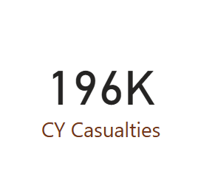

1. Total CY Accidents:

CY ACCIDENT COUNT = TOTALYTD(COUNT(Data[Accident_Index]),Calender[Date])

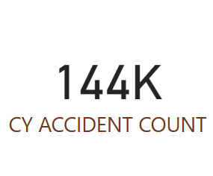

1. CY Fatal Casualties:

FATAL = CALCULATE(SUM(Data[Number_of_Casualties]),YEAR(Calender[Date])=2022,Data[Accident_Severity]="Fatal")

* Filter should be applied in the filter section where Accident_Severity is Fatal.

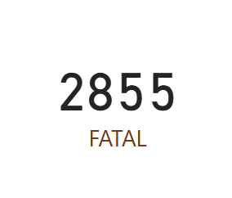

1. CY Serious Casualties:

CY Casualties = TOTALYTD(SUM(Data[Number_of_Casualties]),Calender[Date])

* Filter should be applied in the filter section where Accident_Severity is Serious.

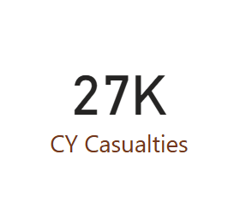

1. CY Slight Casualties:

CY Casualties = TOTALYTD(SUM(Data[Number_of_Casualties]),Calender[Date])

* Filter should be applied in the filter section where Accident_Severity is Serious.

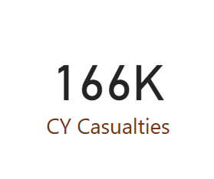

1. YOY Casualties:

YOY Casualties = ( [CY Casualties]-[PR Casulties])/[PR Casulties]

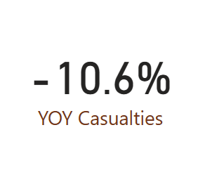

1. YOY Accident Count:

YOY ACCIDENT COUNT = ([CY ACCIDENT COUNT]-[PR ACCIDENT COUNT])/[PR ACCIDENT COUNT]

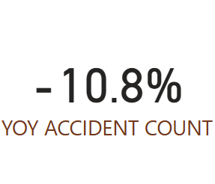

1. YOY Fatal Casualties:

YOY Casualties = ( [CY Casualties]-[PR Casulties])/[PR Casulties]

* Filter should be applied in the filter section where Accident_Severity is Fatal.

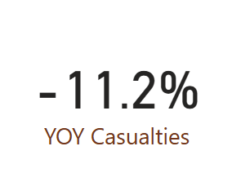

1. YOY Serious Casualties:

YOY Casualties = ( [CY Casualties]-[PR Casulties])/[PR Casulties]

* Filter should be applied in the filter section where Accident_Severity is Serious.

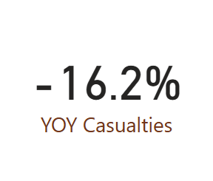

1. YOY Slight Casualties:

YOY Casualties = ( [CY Casualties]-[PR Casulties])/[PR Casulties]

* Filter should be applied in the filter section where Accident_Severity is Slight.

